Lab exercises

Explain the following in your own words using examples and diagrams

Variables
Variables are used to store and represent data, the data can be stored as different types including character, numeric and decimal.
An example of this would be:
int a = 21;
  - Arrays
An array is a systematic arrangement of the same data type that stores data in consecutive memory locations
An example of this would be:
int a[10] = {21,23,25,6,7,8,21,12,41,71};
  - Multi-dimensional arrays
a multi-dimensional array is an array that can store information in two or more dimensions and can have rows and columns.
An example of this would be:
int a[10, 2] = {21,23,25,6,7,8,21,12,41}, {1,2,3,4,5,6,7,8,9};
  - Pointers
pointers are a variable type that stores the addresses or memory location of a stored variable
An example of this would be:
int *ptr, a
Ptr = a;
  - Double pointers
a double pointer is a poiter that points to another pointer which means it points to the memory location of a pointer.
An example of this would be:
int *ptr, a, *dblptr
Ptr = a;
dblptr = ptr;

- Write a program for the below set of statements and give memory snapshots after each of these sets of statements is executed:

- int a=1, b=2, *ptr;
...
ptr = &b;
  - Code:
#include <stdio.h>

int main()
{
int a, b, *ptr;
a= 1;
b= 2;

printf("A is = %d\n", a);
printf("B is = %d\n", b);
printf("ptr = %d\n", ptr);
printf("if ptr is set to b ptr is %d\n", ptr=&b);
return 0;
}

  - Screenshot:
  - 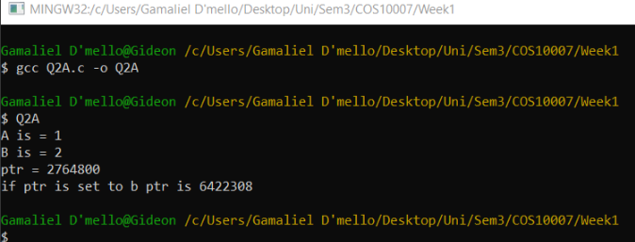

int a=1, b=2, *ptr=&b;
...
a = *ptr;

  - Code:
#include <stdio.h>

int main()
{
int a, b, *ptr =&b;
a= 1;
b= 2;

printf("A is = %d\n", a);
printf("B is = %d\n", b);
printf("ptr = %d\n", ptr);
printf("ptr when saved as the address of b is = %d\n", ptr);
printf("if a is set to show the the data that ptr points to a is %d\n", a = *ptr);
return 0;
}

  - Screenshot:
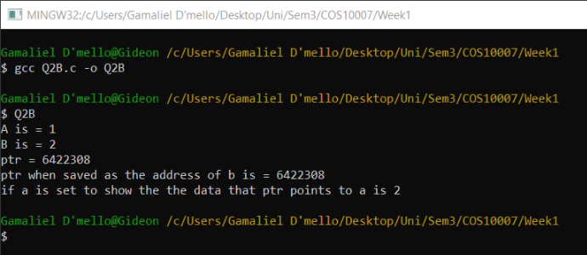

c) int a=1, b=2, c=5, *ptr=&c;
...
b = *ptr;
*ptr = a;
  - Code:
#include <stdio.h>

int main()
{
int a, b, c , *ptr = &c;
a= 1;
b= 2;
c = 5;

printf("A is = %d\n", a);
printf("B is = %d\n", b);
printf("C is = %d\n", c);
printf("ptr when saved as the address of c is = %d\n", ptr);
printf("b is set to the value stored in location the poiter is pointing too which is %d\n",b=*ptr);
printf("pointerr is now pointing the the location of a which is %d\n", *ptr = a);
return 0;
}

  - Screenshot:
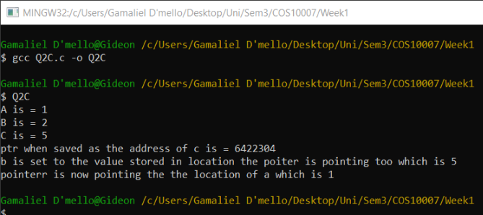

d) int a=1, b=2, c=5, *ptr;
...
ptr = &c; c = b;
a = *ptr;

  - Code:
#include <stdio.h>

int main()
{
int a, b, c , *ptr = &c;
a= 1;
b= 2;
c = 5;

printf("A is = %d\n", a);
printf("B is = %d\n", b);
printf("C is = %d\n", c);
printf("ptr = %d\n", ptr);
printf("pointer is now set to the location of c which is %d\n ", ptr = &c);
printf("the data in b is stored in the variable c and c is now %d\n",c = b);
printf("a stores the value of where the pointer is pointing too and is %d\n", a = *ptr);

return 0;

}

  - Screenshot:
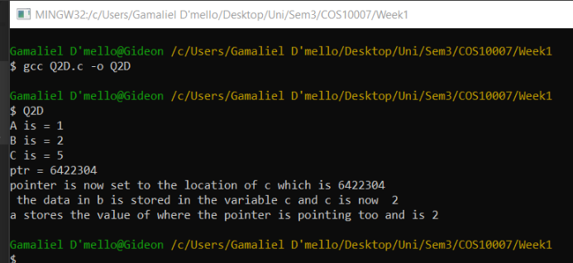

e) double x=15.6, y=10.2, *ptr_1=&y, *ptr_2=&x;
...
*ptr_1 = *ptr_2 + x;

  - Code:
#include <stdio.h>

int main()
{
double x, y, *ptr_1, *ptr_2;
x = 15.6;
y = 10.2;
ptr_1 = &y;
ptr_2 = &x;

printf("X is = %d\n", x);
printf("Y is = %d\n", y);
printf("Ptr_1 is pointing to y and is = %d\n", ptr_1);
printf("Ptr_2 is poiniting to x and is = %d\n", ptr_2);
printf("the value stored in location pointed by ptr_1 is the value located in ptr_2 + x which is %d", *ptr_1 = *ptr_2 + x);
return 0;
}

  - Screenshot:
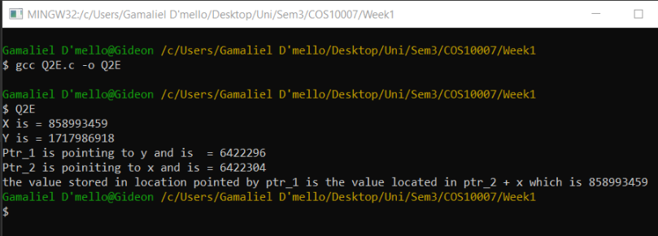

f) int w=10, x=2, *ptr_2=&x;
...
*ptr_2 -= w;

  - Code:

#include <stdio.h>

int main()
{
int w, x, *ptr_2 = &x;
w= 10;
x= 2;

printf("W is = %d\n", W);
printf("X is = %d\n", X);
printf("Ptr_2 is poiniting to x and is = %d\n", ptr_2);
printf("ptr is pointing to the location of w and is %d", ptr_2-=w);

return 0;
}

  - Screenshot:

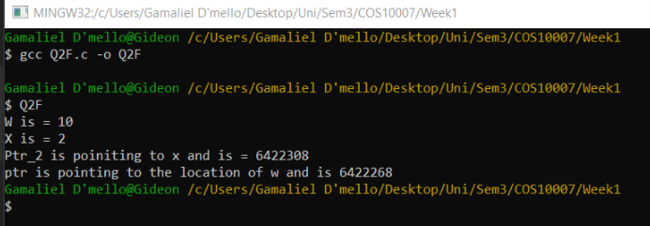
Exercises:

- Show the contents of the variables that have changed after executing each of the following codes (Draw table or figure to explain).

a) p1 = &i;
*p1 = 8;

Variable | Address | Value
I | 1024 | Random value (RV), 8
P1 | 2048 | pointing to i

b) p1 = &m[0]; p1 = p1 + 2;
*p1 = *p1 + 8;
Variable | Address | Value
M[0] | 1024 | RV
M[1] | 1028 | RV_2
M[2] | 1032 | RV_3, RV_3 + 8
P1 | 2048 | Pointing to m[0], m[2]

c) p1 = &i;
p3 = m;
*(p3 + 1) = *p3 + *p1;
Variable | Address | Value
I | 1024 | RV
M[0] | 2048 | RV
M[1] | 2052 | Value in p3(m[0]) + value in p1
P1 | 3096 | Pointing to i
P3 | 4192 | Pointing to m[0], m[1]

d) p1 = m + 2; p3 = p1 + 1;
i = *p1 + *p3;

Variable | Address | Value
M[0] | 1024 | RV
M[1] | 1028 | RV_2
M[2] | 1032 | RV_3
I | 2048 | RV_3 + RV_2
P1 | 3096 | Pointing to m[0], m[2]
P3 | 4192 | pointing to (p1 + 1) = m[1])

e) for(i = 0; i <= 4; ++i) q[i] = m + i;
for(i = 0; i <= 4; ++i)
*(a + i) = *q[i] + a[i];

Variable | Address | Value
I | 1024 | 0, 2, 4
Q[0] | 2048 | m + 0
Q[2] | 2052 | m + 2
Q[4] | 2056 | M + 4
m | 3096 | RV
A[0] | 4192 | Ptr_q + a[0]
A[2] | 4196 | Ptr_q + a[2]
A[4] | 4200 | Ptr_q + a[[4]
Ptr_a | 5284 | Pointing to a[0], a[2], a[4]
Ptr_q | 6348 | Pointing to q[0], q[2], q[4]

f) for(i = 4; i >= 0; --i)
{
q[i] = &m[4 – i];
*p2 = *q[i] + *(a + i);
}

Variable | Address | Value
i | 1024 | 4
Q[i] | 2048 | Value of m
Q[0]
*q[i] | 2000 | Pointing to q[0]
a | 3000 | A+4,
M[4-i] = 0 | 3096 | RV
M[1] | 4000
P2 | 4500 | Q[i] + *(a+i}

- Assume that an array g is defined with the following statement:

int g[]={50,10,6,81,130,4,9};
int *ptr1=&g[0], *ptr2=&g[3];

Give a diagram of the memory allocation, including the array values. Also indicate the offset values from the initial value in the array. Using this information, give the value of the following references:

1. *g
2. *(g+1)
3. *g+1
4. *(g+5)
- *ptr1
- *ptr2
7. *(ptr1+1)
8. *(ptr2+2)

*g | 50
*(g+1) | 10
*g+1 | 51
*(g+5) | 4
*ptr1 | 50
*ptr2 | 81
*(ptr1+1) | 130
*(ptr2+2) | 4

5. Assume that an integer array x is defined by the following statements:

int x[2][4]={{1,8,7,6},{2,4,-1,0}}, *xptr=&x[0][0];

Draw a memory allocation diagram, and give the value indicated by each of the following references:

1. *xptr = 1, 2
2. *(xptr+2)= 7, -1
3. *xptr + 2 = 3, 4
4. *(xptr+1) + *(xptr+3) = 8, 4 + 6, 0 = 10, 4

6. Write a simple function that returns a pointer.

#include <stdio.h>

int point (int a)
{
int *ptr1;
*ptr1 = a;

return *ptr1;
}
int main ()
{
int a, b;
a = 7;
b=point(a);
printf("value is %d and pointer is %d ”, a, b);

return 0;
}

